Income Tax System
Issues:
1. Auto Calculation of columns of all the stage is required.
2. Report Format need to be set for all the stages.
3. Tracking of all work and it should give on which stage it is present
4. Drop down need for year in all pages
5. Year dropdown should be AY 2014-15 , AY 2015-16 ...AY 2023-24 like that
6. after addition one record , there should be option to go to home window
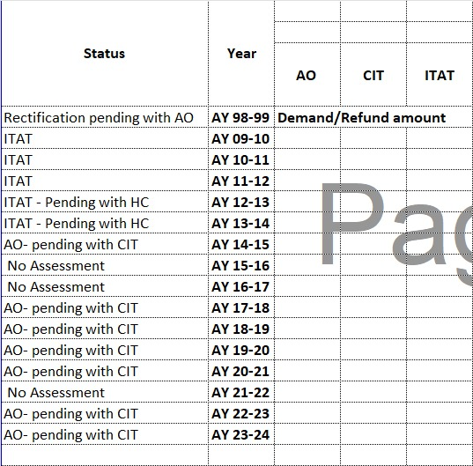
7. This is another format for final year-wise summary chart
in blank columns there will be amounts

Income Tax Return ( ITR ) Model :

Formulas:

- Year : AY yyyy-yyyy

- Gross Total Income: (disallowance_37 + gross_total_income)
- Disallowance 14A:
- Disallowance 37: (disallowance_14a + disallowance_37)

- deduction_80ia_business :
- deduction_80ia_misc :
- deduction_80ia_other :
- deduction_sec37_disallowance : (deduction_80ia_business + deduction_80ia_misc + deduction_80ia_other - 1.35)
- deduction_80g :

- net_taxable_income :(gross_total_income - deduction_sec37_disallowance - deduction_80g)

- tax_30_percent : (net_taxable_income * 30%)
- tax_book_profit_18_5 :

- tax_payable :(tax_book_profit_18_5)

- surcharge_12 :(tax_payable * 12%)
- edu_cess_3 : ((tax_payable + surcharge_12) * 3%)

- total_tax_payable :(tax_payable +surcharge_12+edu_cess_3 )
- mat_credit :

- interest_234c :
- total_tax : (total_tax_payable + mat_credit + interest_234c)

- advance_tax :
- tds :
- tcs :
- tax_on_assessment : (advance_tax + tds + tcs )

- refund : (total_tax - tax_on_assessment)

Income Tax Return ( ITR ) Model :

Formulas:

- 1.Year:
- gross_total_income: (disallowance_37 + gross_total_income)
- disallowance_14a :
- disallowance_37 : (disallowance_14a + disallowance_37)

- deduction_80ia_business :
- deduction_80ia_misc :
- deduction_80ia_other :
- deduction_sec37_disallowance : (deduction_80ia_business + deduction_80ia_misc + deduction_80ia_other - 1.35)
- deduction_80g :

- net_taxable_income :(gross_total_income - deduction_sec37_disallowance - deduction_80g)

- tax_30_percent : (net_taxable_income * 30%)
- tax_book_profit_18_5 :

- tax_payable :(tax_book_profit_18_5)

- surcharge_12 :(tax_payable * 12%)
- edu_cess_3 : ((tax_payable + surcharge_12) * 3%)

- total_tax_payable :(tax_payable +surcharge_12+edu_cess_3 )
- mat_credit :

- interest_234c :
- total_tax : (total_tax_payable + mat_credit + interest_234c)

- advance_tax :
- tds :
- tcs :
- tax_on_assessment : (advance_tax + tds + tcs )

- refund : (total_tax - tax_on_assessment)

AO Form model :

- Year:
- gross_total_income:
- disallowance_14a :
- disallowance_37 :

- deduction_80ia_business :
- deduction_sec37_disallowance :
- deduction_80g :
- net_taxable_income :(gross_total_income + disallowance_14a + disallowance_37)- (deduction_80ia_business + deduction_sec37_disallowance) - deduction_80g

- tax_30_percent : (net_taxable_income * 30%)
- tax_book_profit_18_5 :

- tax_payable :(tax_book_profit_18_5)

- surcharge_12 :(tax_30_percent * 12%)
- edu_cess_3 : ((tax_30_percent + surcharge_12) * 3%)

- total_tax_payable :(tax_30_percen +surcharge_12+edu_cess_3 )

- mat_credit : (((tax_30_percent + tax_book_profit_18_5) * 12%) * 3)

- interest_234c :
- total_tax :(total_tax_payable + mat_credit + interest_234c)

- advance_tax :
- tds :
- tcs :
- tax_on_assessment :(advance_tax + tds + tcs )

- refund :(total_tax - tax_on_assessment)

CIT model

- Year:
- gross_total_income:
- disallowance_14a :
- disallowance_37 :

- deduction_80ia_business :
- deduction_sec37_disallowance :

- deduction_80g :

- net_taxable_income :(gross_total_income + disallowance_14a + disallowance_37)- (deduction_80ia_business + deduction_sec37_disallowance) - deduction_80g

- tax_30_percent : (net_taxable_income * 30%)
- tax_book_profit_18_5 :

- tax_payable :(tax_book_profit_18_5)

- surcharge_12 :(tax_book_profit_18_5 * 12%)
- edu_cess_3 : ((tax_book_profit_18_5 + surcharge_12) * 3%)

- total_tax_payable :(tax_payable + surcharge_12 + edu_cess_3 )
- mat_credit :

- interest_234c :
- total_tax :(total_tax_payable + mat_credit + interest_234c)

- advance_tax :
- tds :
- tcs :
- tax_on_assessment :(advance_tax + tds + tcs )

- refund :(total_tax - tax_on_assessment)

